**What is a computer?**

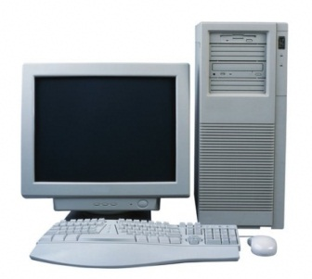

An electronic device operating on instructions stored in its own memory, which can accept ***input***

**Input devices:**

**PC Video Camera/ webcam Mouse Keyboard**

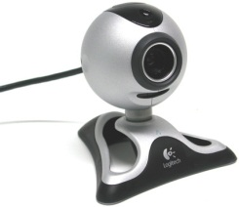 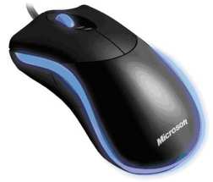 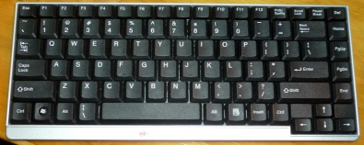

**Microphone Scanner Digital camera**

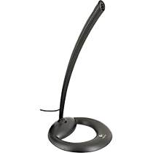 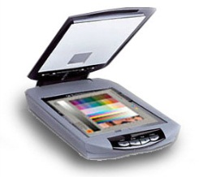 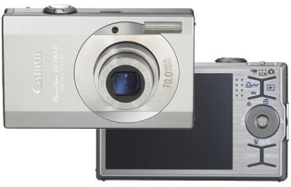

***processes*** the data according to specified rules

**processor** *(this is inside the computer)*

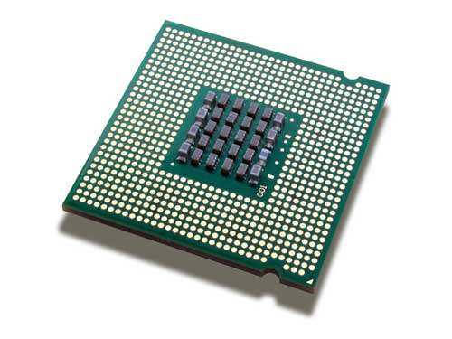

produces results known as ***outputs***

**Output devices:**

**Printer MP3 player Monitor**

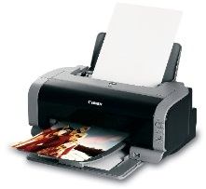 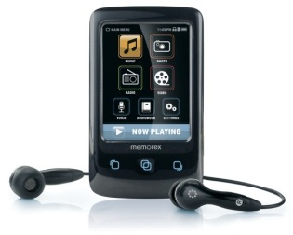 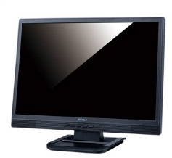

and stores the results ***(storage)*** for future use.

**Storage devices:**

**CD/DVD drive Hard drive** *(this is inside)* **USB Flash drive**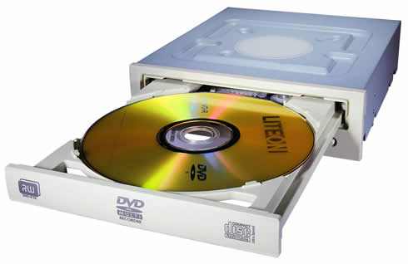 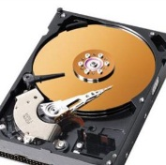 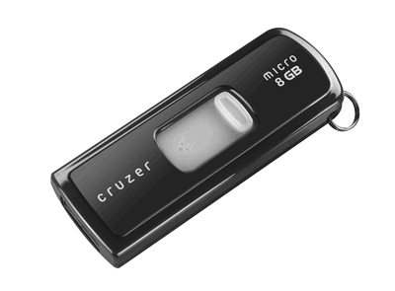

**Card reader/writer External hard drive**

